Unit One

Unit One was a group of painters, sculptors and architects, formed in London in 1933 by the artist Paul Nash. ‘Unit’ referred to the group’s unity of purpose, and ‘One’ to each member’s individual style. Its unifying aim was to reflect contemporary modernism, including Surrealism and abstraction. The painters were John Armstrong, Edwin Burra, Tristram Hillier and Paul Nash – all influenced by Surrealism – and the abstract artists John Bigge, Ben Nicholson and Edward Wadsworth. The sculptors, Barbara Hepworth and Henry Moore, were making bio-morphic forms, while the architects Wells Coates and Colin Lucas were designing in a modernist style. The group launched with a London exhibition in 1934 which then toured provincially. A book, Unit One, edited by the art critic Herbert Read, accompanied the exhibition and carried statements by all the group’s members. The exhibition and book generated intense public controversy about the nature of modern art, although the group itself broke up in 1935 as a result of differences between its members.

Nash originally painted landscapes, influenced by Cubism and Post-Impressionism, but by 1930 was becoming dissatisfied with this approach. He and Burra then visited Paris to study new developments in art, and on returning to England, Nash organised an exhibition entitled Recent Developments in British Painting. This included new work by Burra, Nicholson, Bigge, Armstrong and Wadsworth who all then joined Unit One. What was most significant for these artists was not the growing animosity in Paris between abstraction and Surrealism, but that both movements were modern in the sense of being contemporary cultural developments.

Nash and Read emphasised that Unit One was not concerned with the promotion of any single theory or style. Read stated that “it does not stand for any new principle in art”, while Nash acknowledged that the members’ individual artistic beliefs varied. What brought them together, said Nash, was a common concern for “the expression of a truly contemporary spirit, for that thing which is recognised as particularly of today.” The implication was that they considered much English art to be backward-looking or rooted in provincial romanticism. Instead, the group embraced the modernist European concept of a unity of approach between painting, sculpture and architecture in the creation of art for the contemporary world.

While Nash emphasised this broad commonality of approach, the statements by individual members and the visual character of their works differed widely. Thus, while Wadsworth wrote dismissively in the Unit One book about pictures deriving from the appearance of “an attractive little bit of Nature”, Hepworth proclaimed that “contemplation of Nature” generated “some universal or abstract vision of beauty.” Similarly, Bigge argued that the new art should be characterised by “precision, clarity and simplicity” and produced related abstract imagery, while Burra’s surrealist figurative paintings were complex and “loaded with luxuriance.” Even among the abstract artists there were important differences of approach, varying from Nicholson’s orthogonal, geometric reliefs to Wadsworth’s free-floating, biomorphic forms. But, despite many differences, Unit One certainly met its objectives of showcasing work then perceived as modern, as was demonstrated by the extensive, if generally hostile, reception of its exhibition by much of the media. Press accounts described some works in the exhibition as meaningless, repulsive and even degenerative, while the critic Geoffrey Grigson wrote of the group’s disunion of styles.

Given the differences within the group – particularly between abstraction and surrealism – it is not surprising that Unit One expired in 1935. However, the interest it had generated resulted in other galleries launching separate exhibitions of surrealist and abstract art; these were developments in contemporary art in Britain for which Unit One had provided an early platform.

References and further reading

Black, J. (2005) Edward Wadsworth, London: Phillip Wilson Publishers
Causey A.(1980) Paul Nash, Oxford: Oxford University Press
Checkland S.J. (2000) Ben Nicholson, the Vicious Circle of his Life and Art, London:
John Murray
Harrison C. (1981) English Art and Modernism, New Haven and London: Yale
University Press
Read H. (1934), Unit One, London: Cassell and Co.
Remy M. (1999) Surrealism in Britain, Aldershot: Ashgate

Images
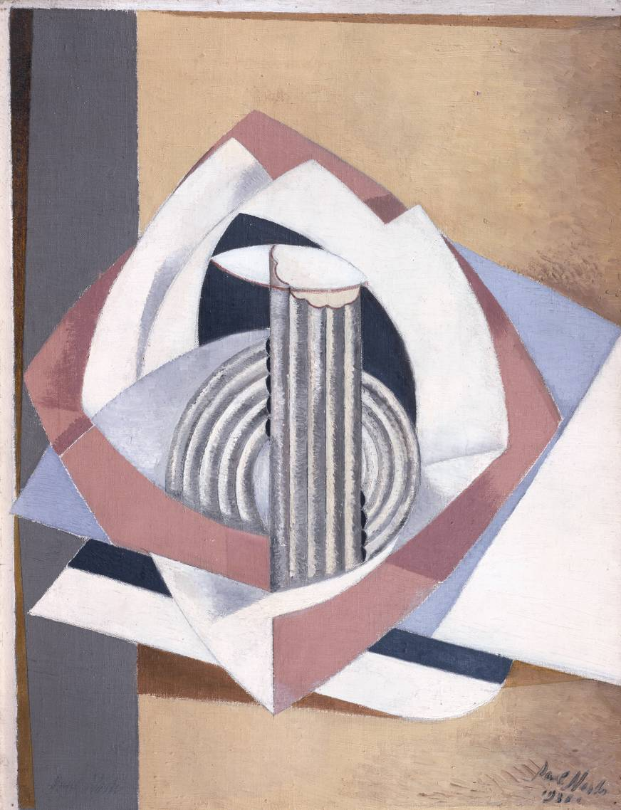
Paul Nash, Kinetic Feature, 1931, oil on canvas, 66 x 50.8 cms, Tate

www.tate.org.uk/art/artworks/nash-kinetic-feature-t00734

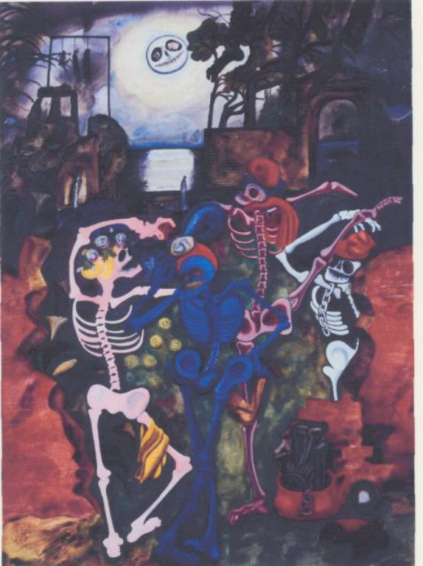
Edward Burra, Dancing Skeletons, 1934, Gouache on paper, 78.7 x 55.9 cms, Tate.

www.tate.org.uk/art/artworks/burra-dancing-skeletons-n05005

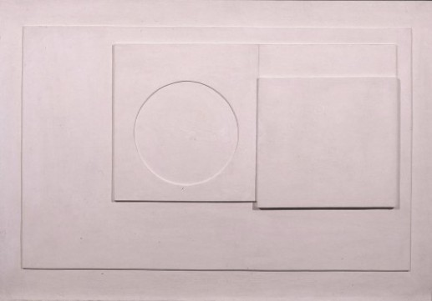
Ben Nicholson, Relief, 1935, oil on wood, 54.5 x 80 cms., British Council

visualarts.britishcouncil.org/collection/artist/5/1773/object/43125

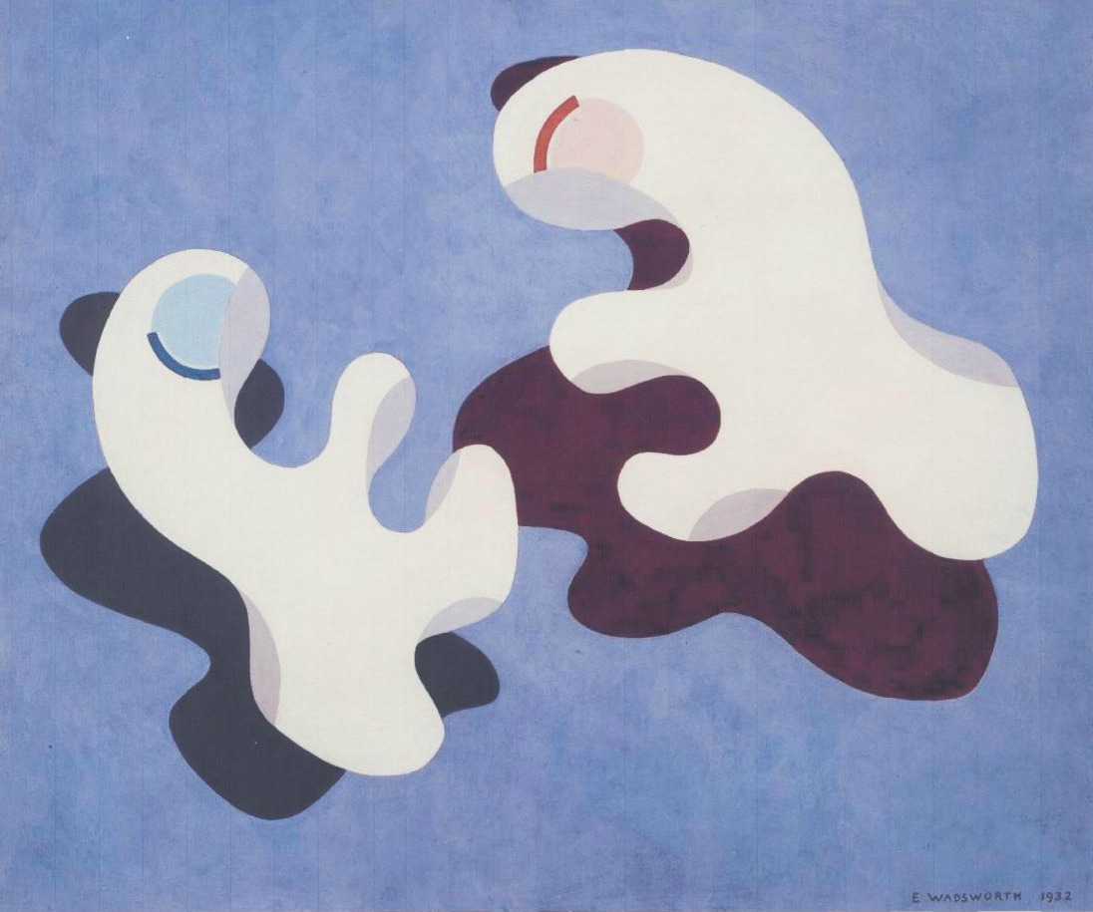
Edward Wadsworth, Dux et Comes 1, 1932, tempera on canvas, 50.8 x 61 cms., Tate

www,tate.org.uk’art/artworks/wadsworth-dux-et-comes-I-t01124

